**MIDDLETON CHENEY FOOTBALL CLUB**

**ANNUAL GENERAL MEETING**

**1977**

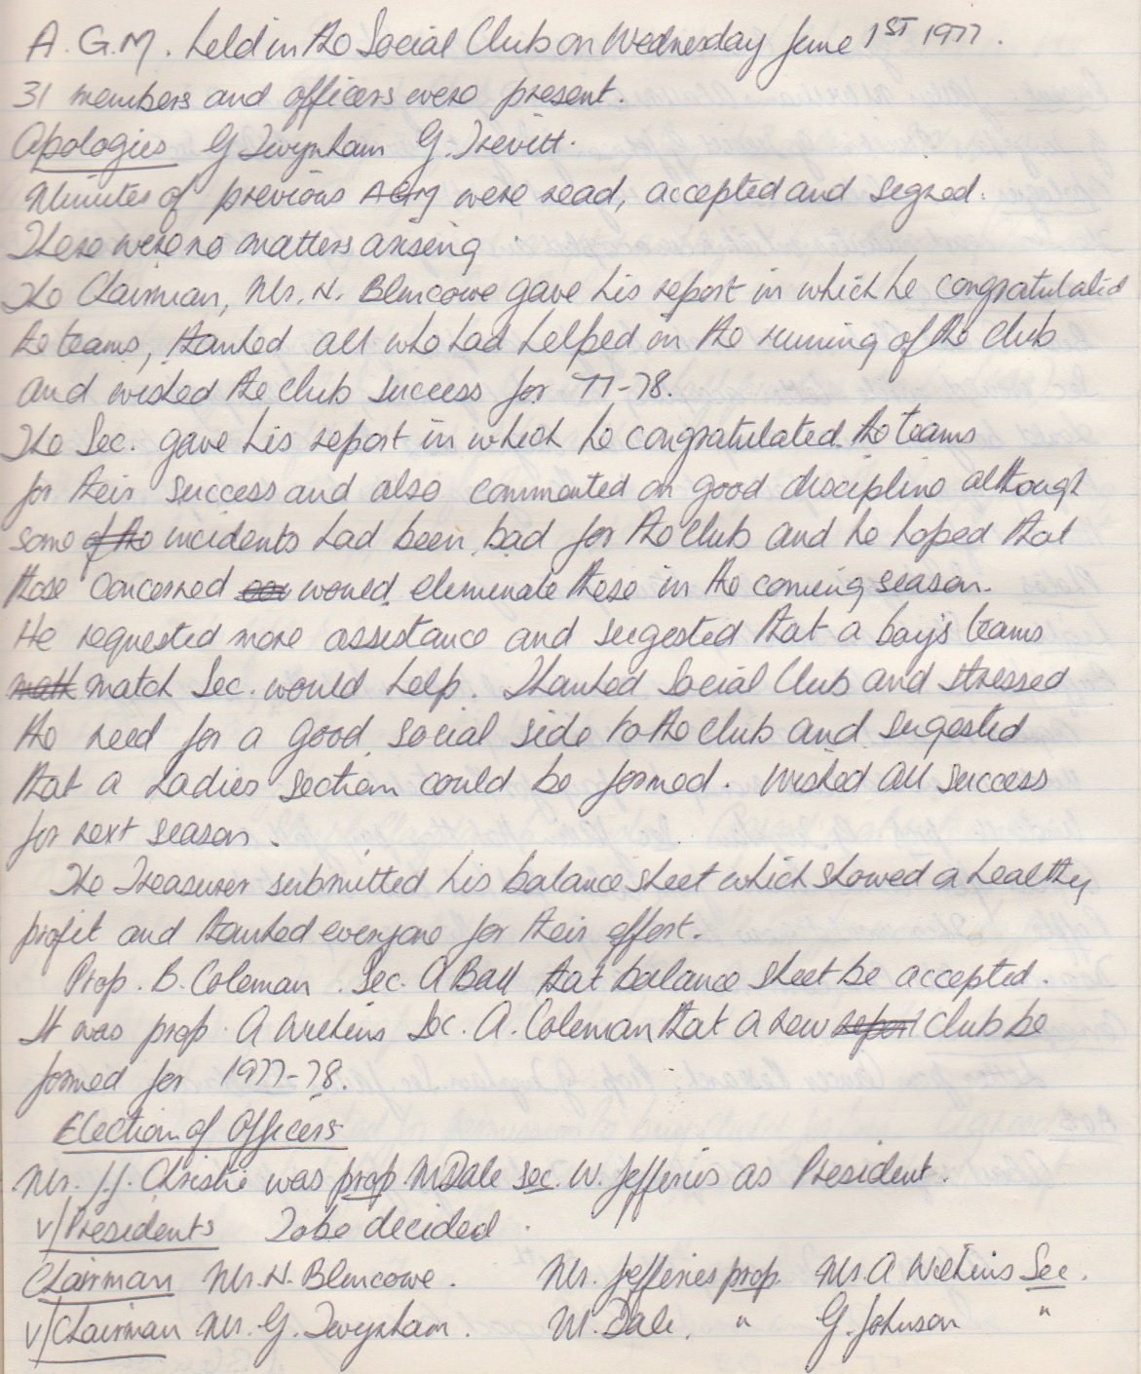

**Continued**

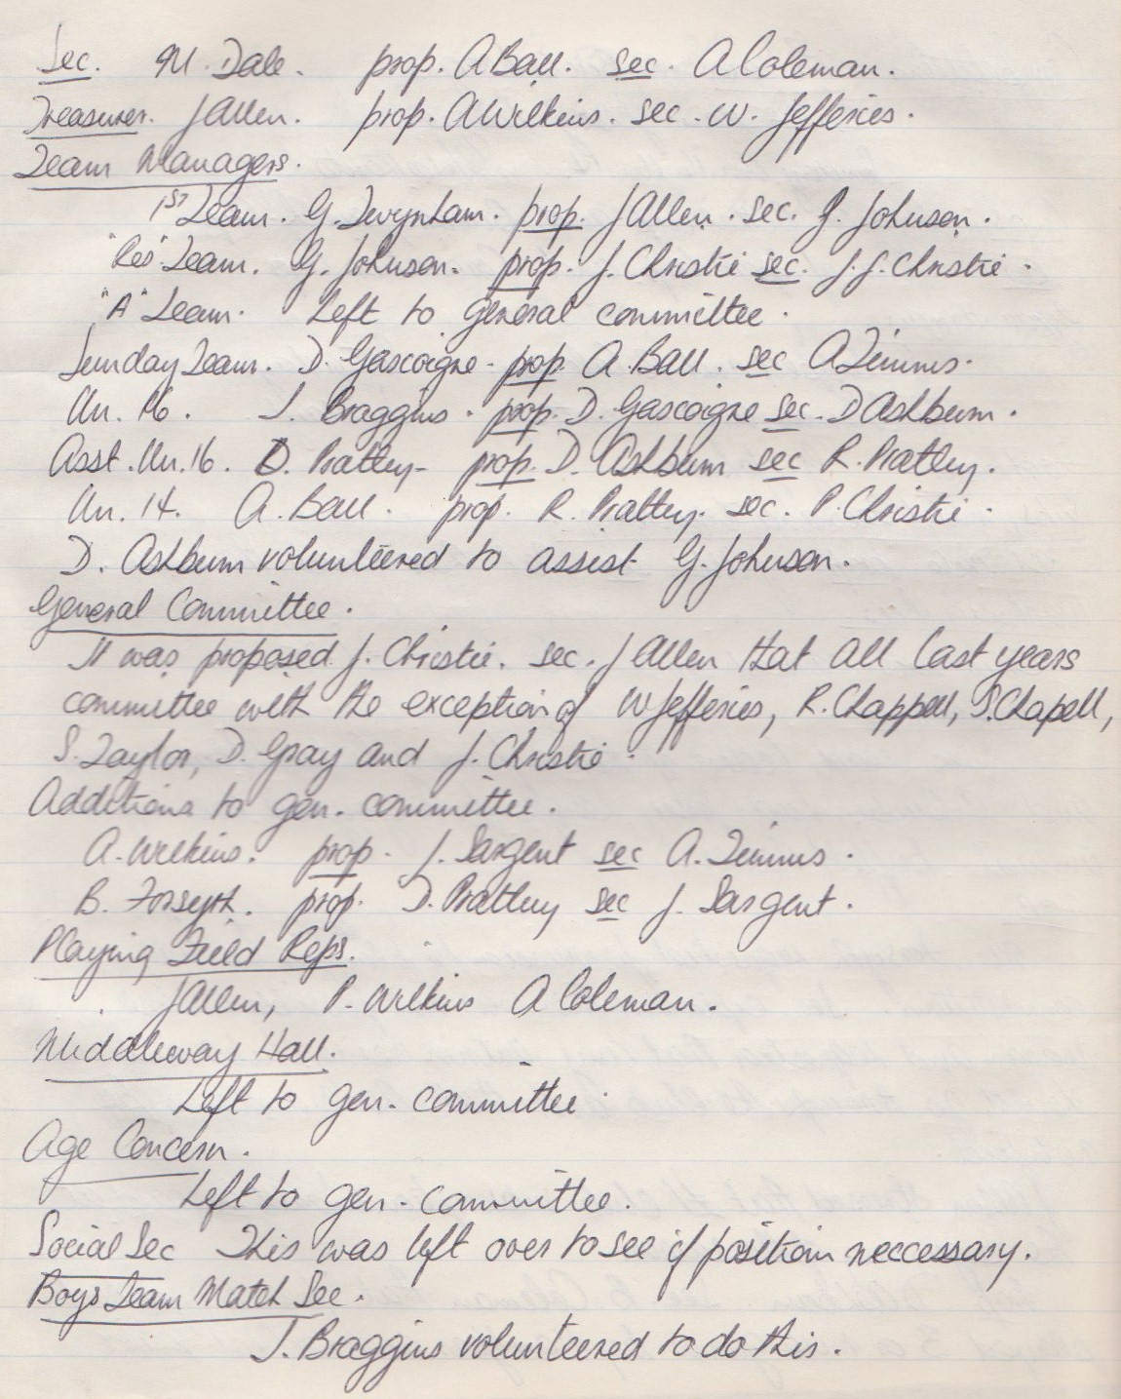

**Continued**

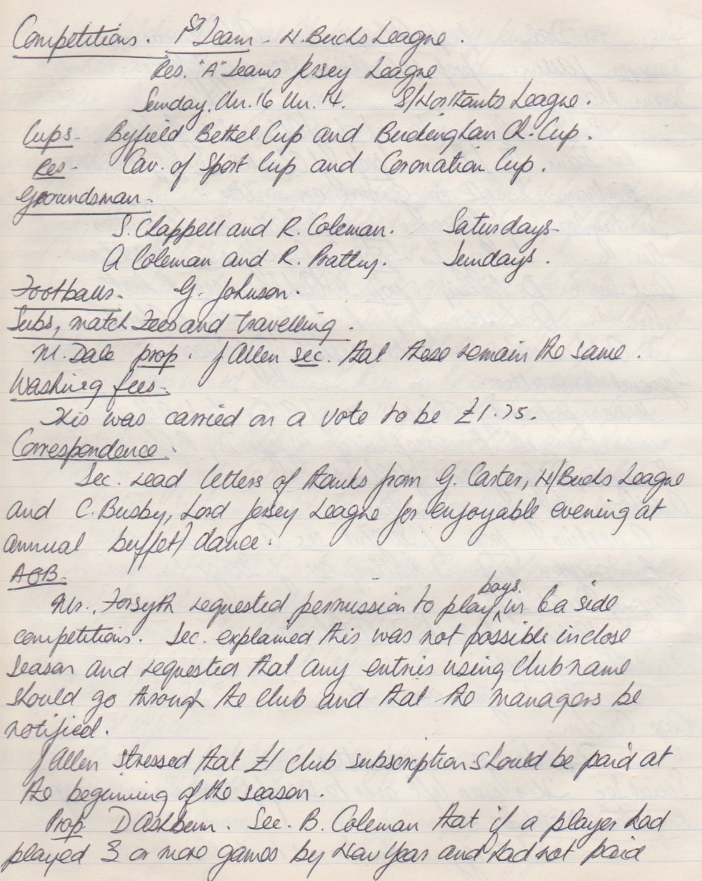

**Continued**

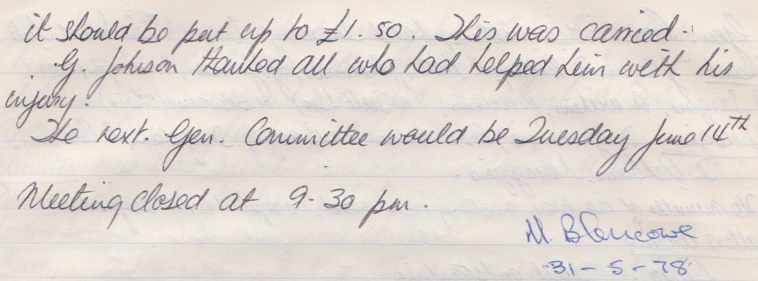

**General Committee Meeting**

**June 14th 1977**

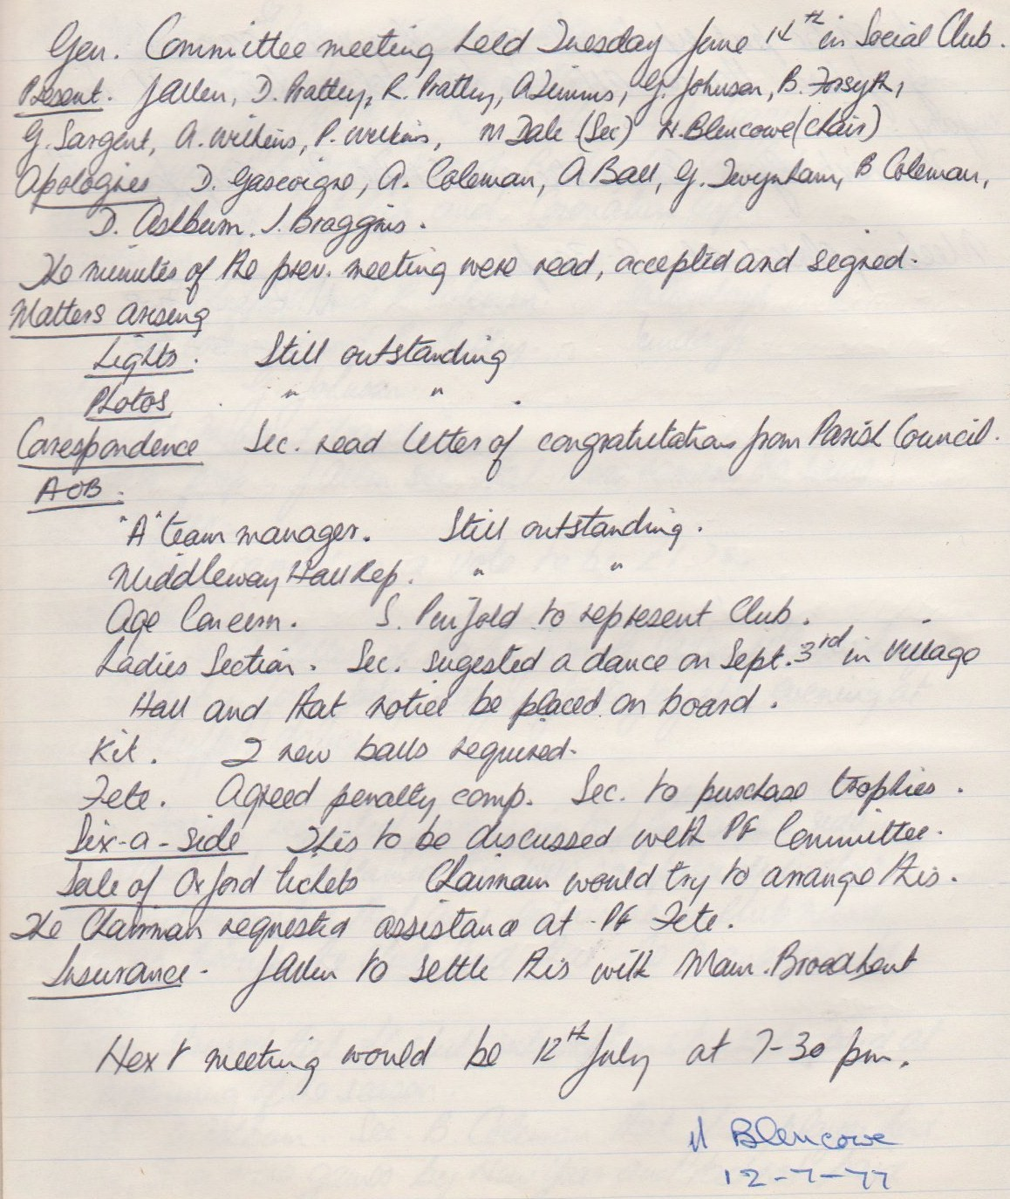

**General Committee Meeting**

**July 12th 1977**

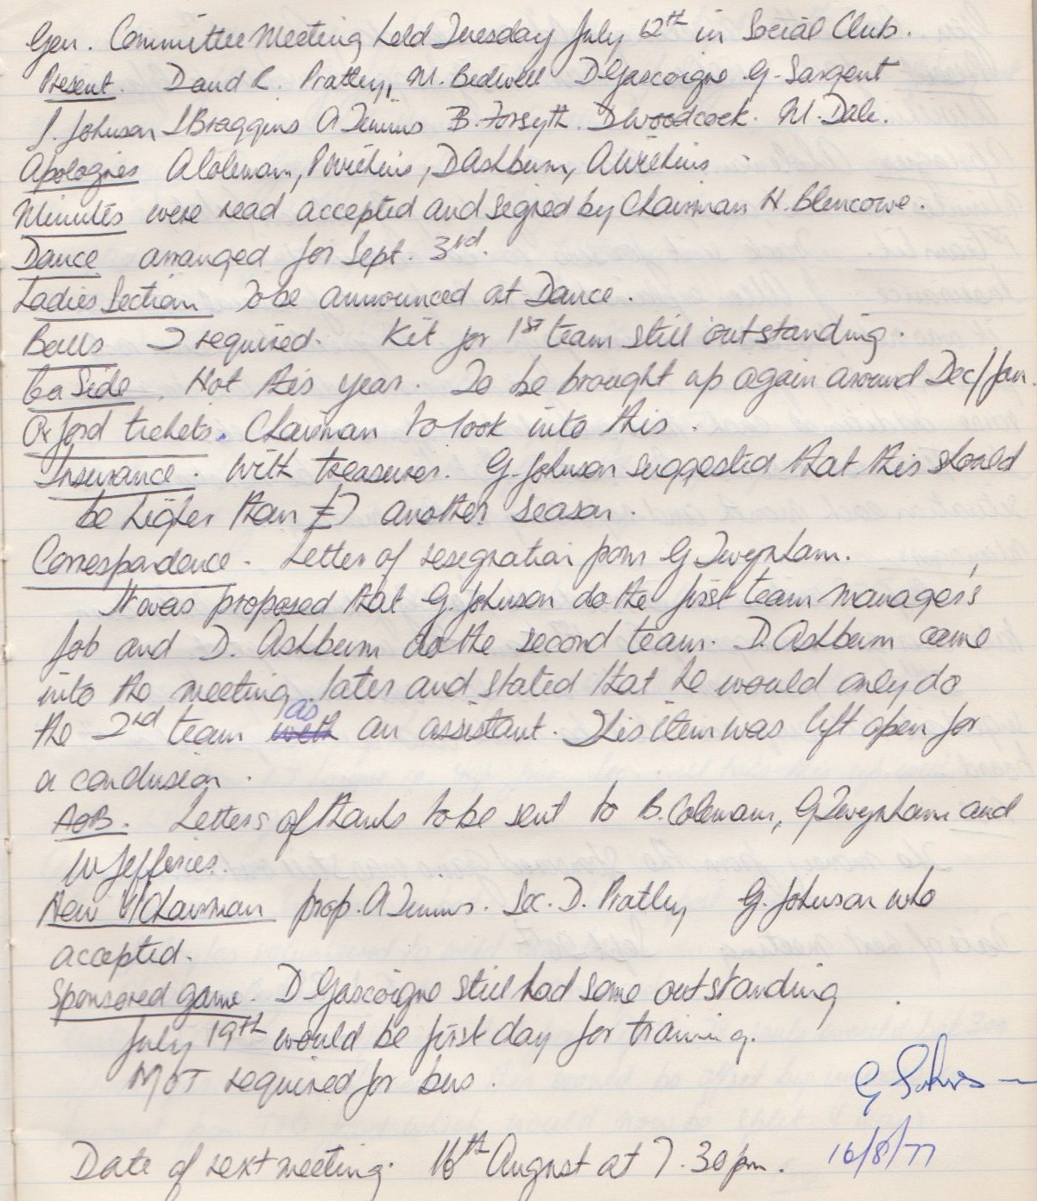

**General Committee Meeting**

**August 16th 1977**

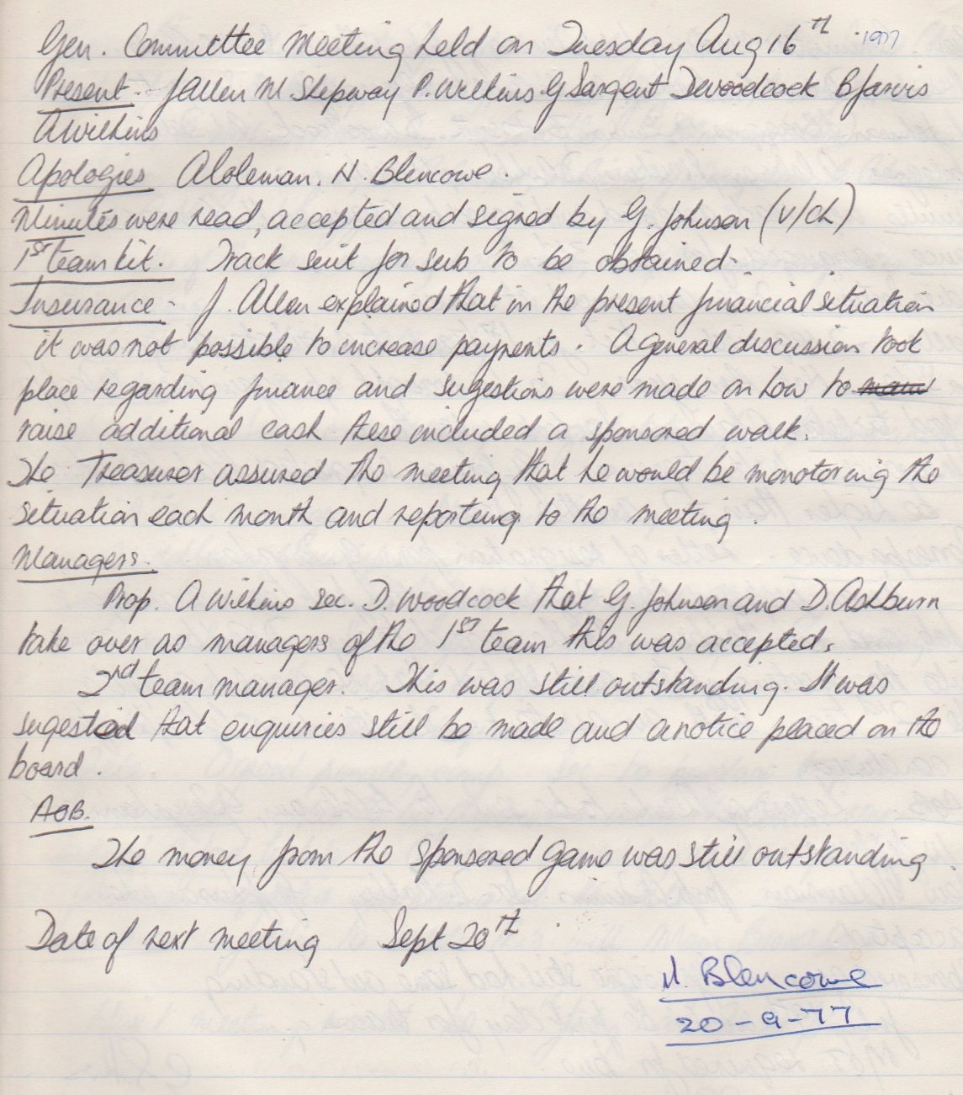

**General Committee Meeting**

**September 20th 1977**

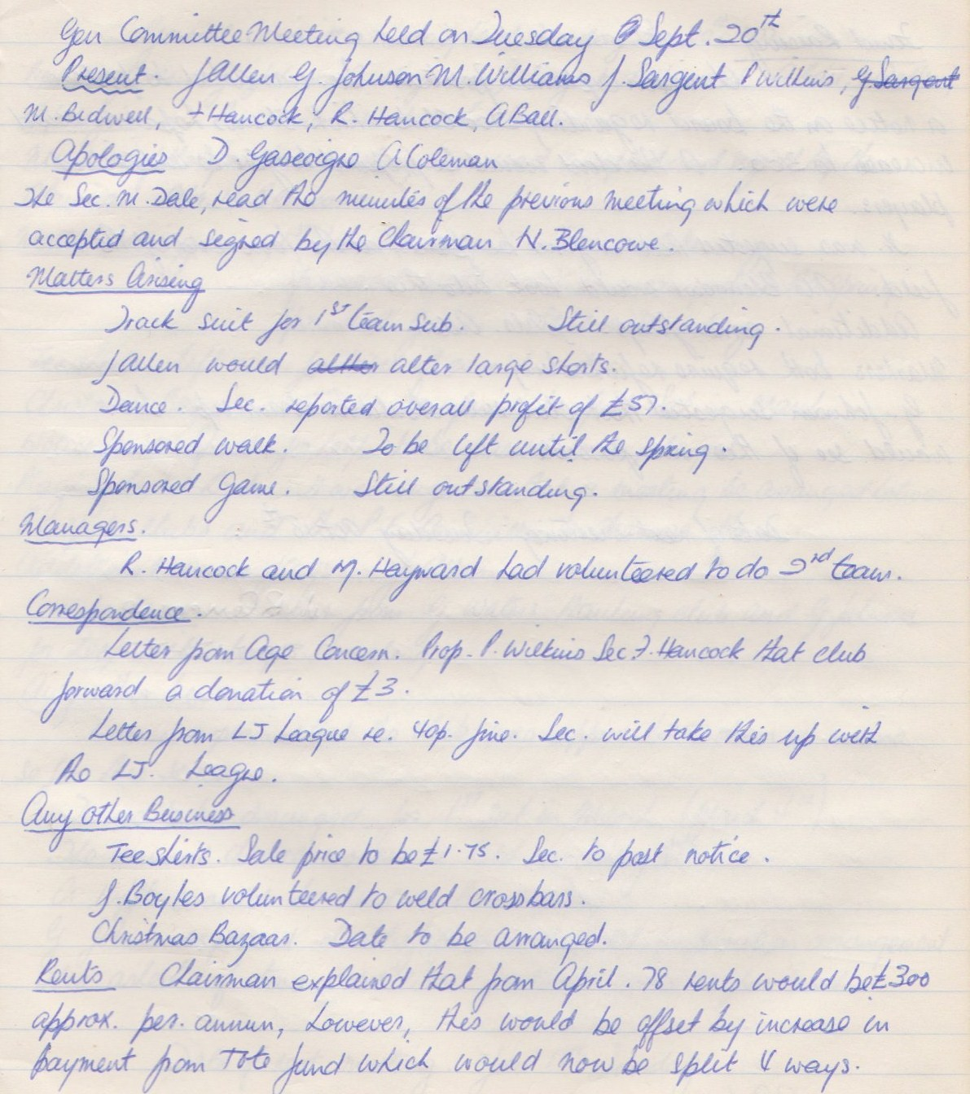

**Continued**

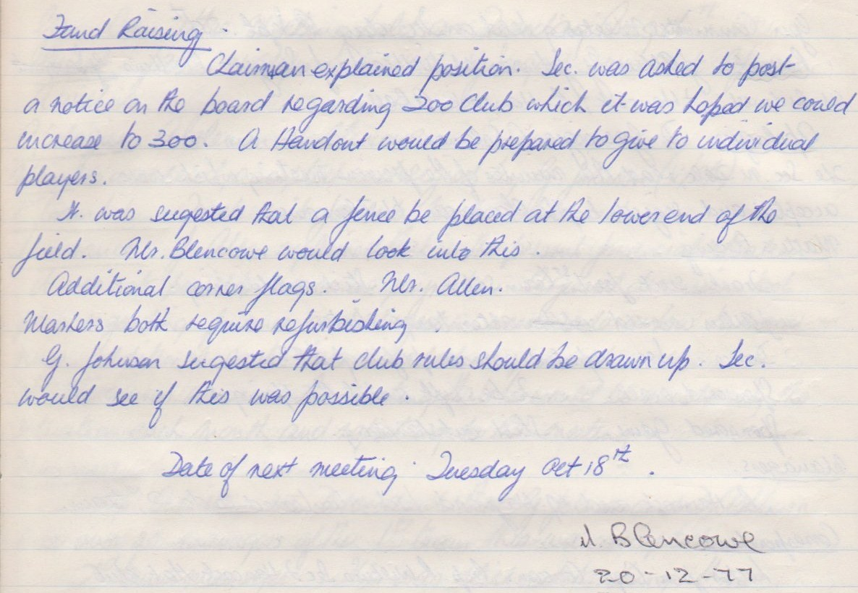

**General Committee Meeting**

**December 20th 1977**

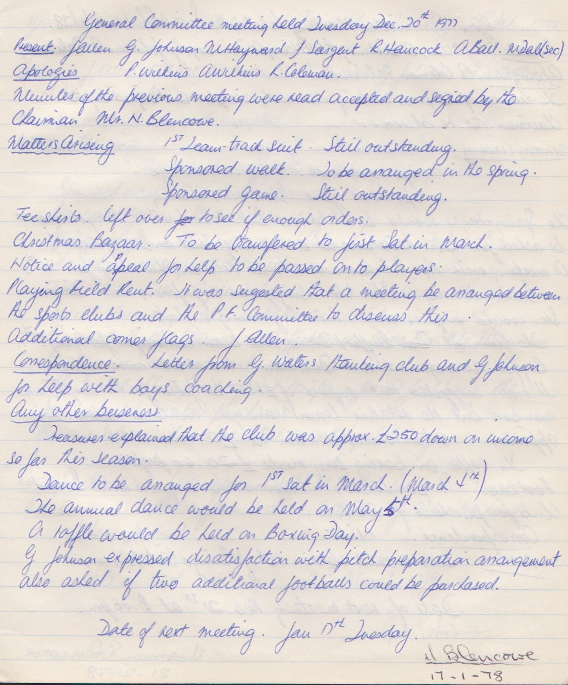

**General Committee Meeting**

**January 17th 1978**

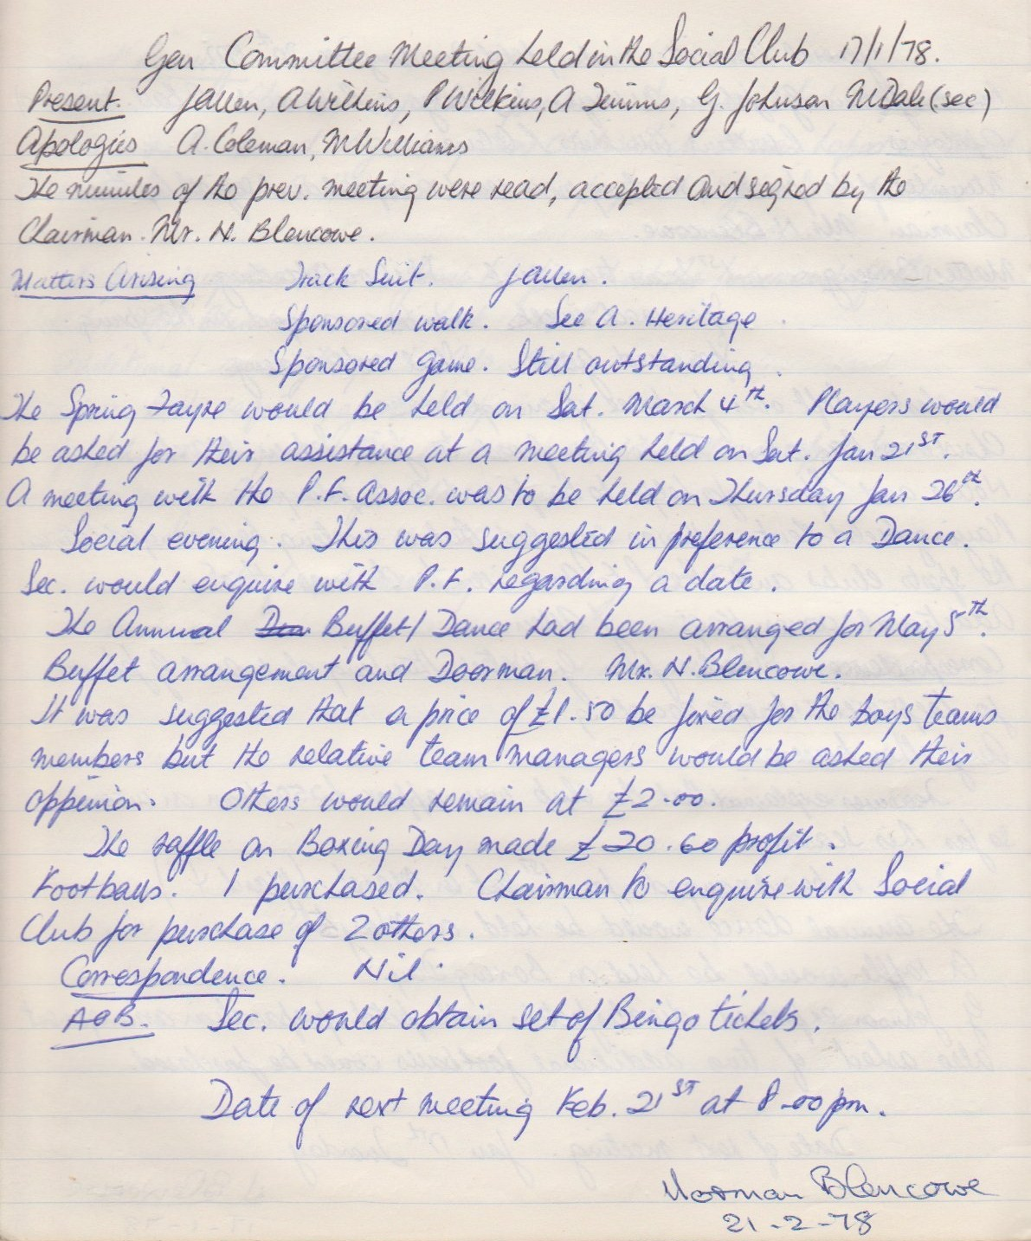

**General Committee Meeting**

**February 21st 1978**

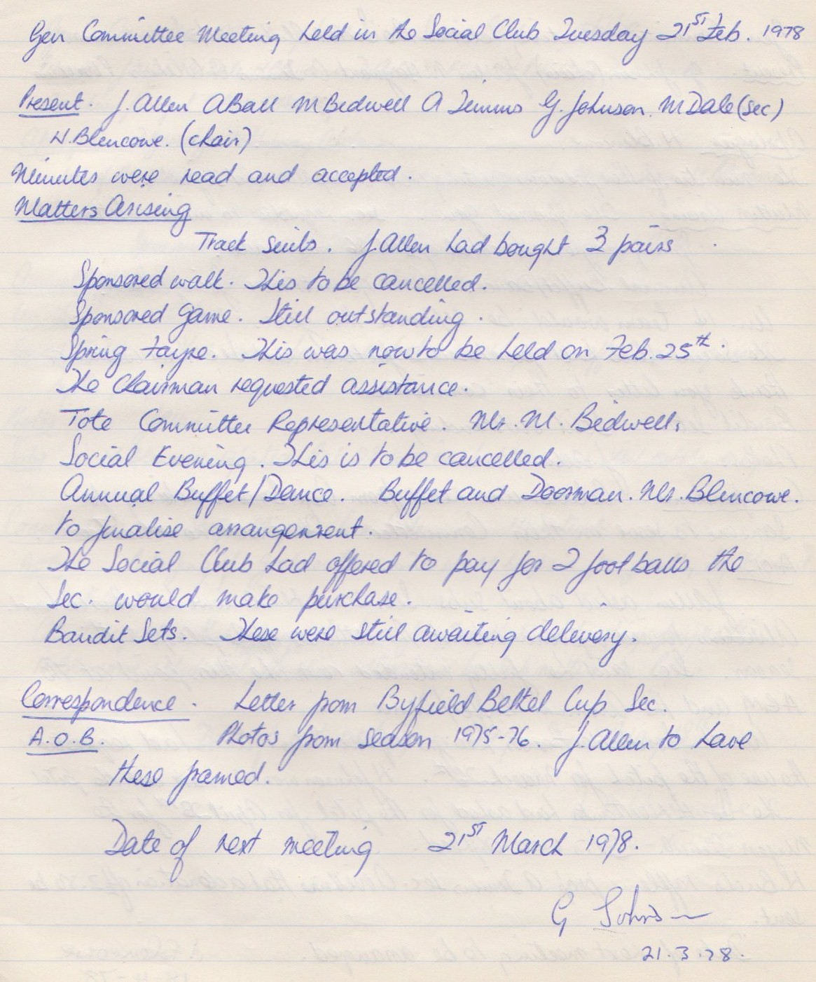

**General Committee Meeting**

**March 21st 1978**

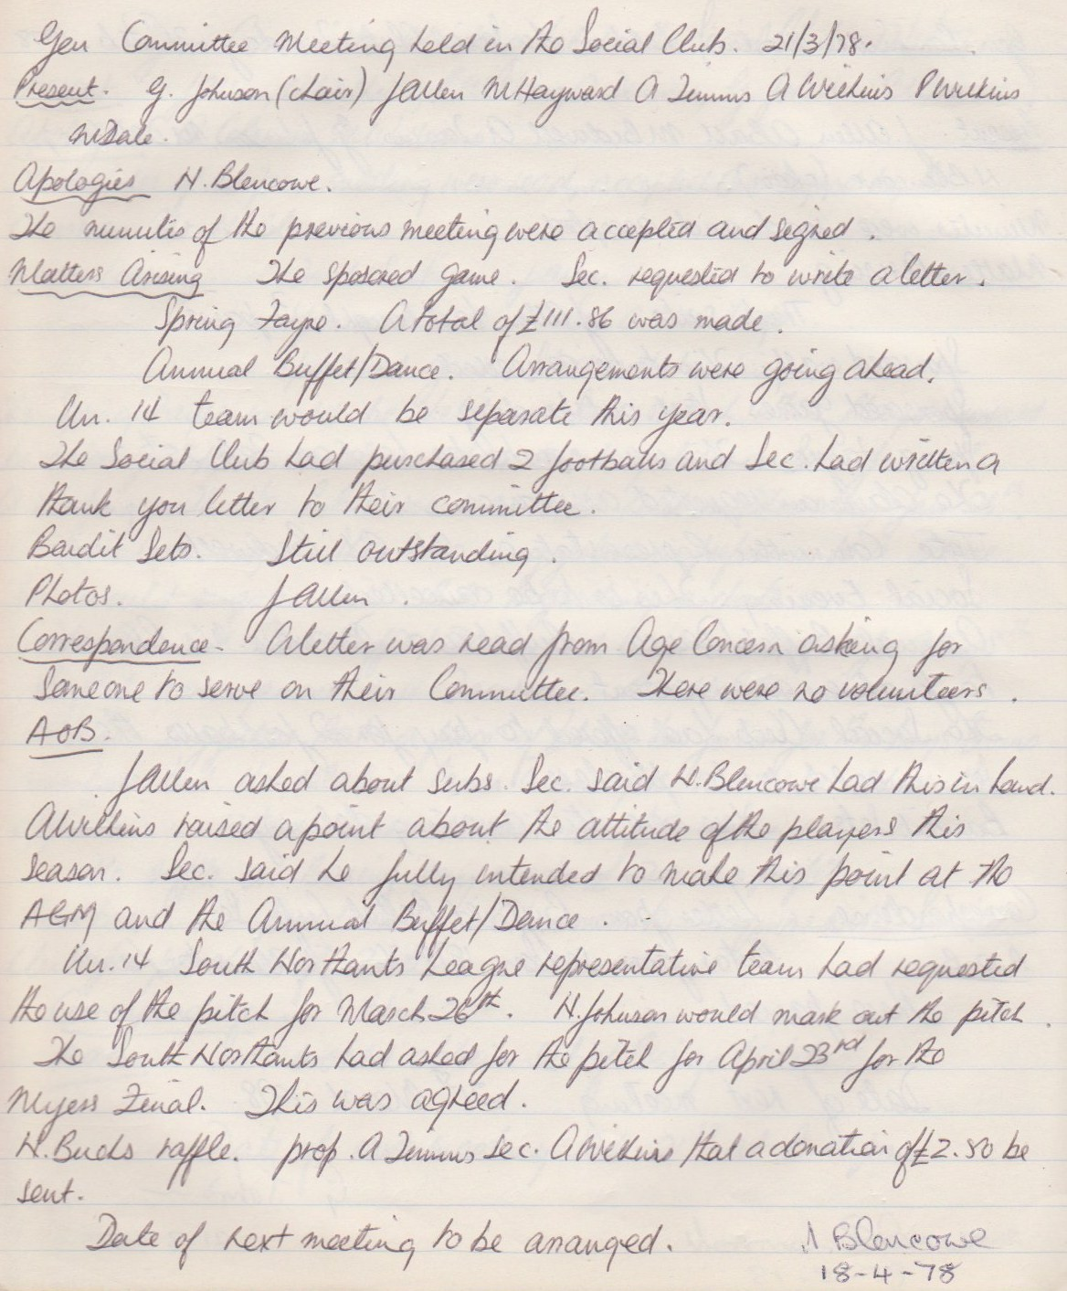

**General Committee Meeting**

**April 18th 1978**

